Suggested Grade: 2nd-3rd | Facilitator: | Grade: | Lesson Date(s):
Book Title and Author(s)/Illustrator(s): Hot, Hot Roti for Dada-ji - Author: F. Zia; illustrator: Ken Min
Theme(s)/Big Idea(s): It is important to spend time with grandparents to learn about cultural traditions; family; food

VOCABULARY PLAN
Focus word & kid-friendly definition: Culture - how a group of people dress, talk, write, eat, and live their lives. This includes specific traditions, holidays, religions, customs, and food!
Image/symbol: see attached images of different flatbreads (like roti) from around the world | Gesture: n/a
Use in context: Using the attached images: For example, in different cultures around the world, they have different ways of making flatbreads. In the book today, a boy named Aneel is part of a culture from India where they eat roti. Other parts of their culture include practicing meditation, lighting incense, and doing yoga.
Prompt kids to use in context: What culture are you a part of? What special foods are a part of your culture?
Bridge to book: In the book Hot, Hot Roti for Dada-ji by F. Zia and illustrated by Ken Min, we will learn about Aneel and his family’s culture. We will hear about some foods they eat and the stories they tell.

BEFORE READING
write questions and student interaction (T/T, S/J, Act-it-out)
- Review RR expectations  - Introduce Book/Author/Illustrator  - Teach focus vocab word ( See plan above)  - Ask 1-2 questions to activate prior knowledge/ solicit predictions |  | Q1. What is a food from your culture? Close your eyes and think of that food. Think of how it smells when it’s cooking, how it smells right before you eat it, what does it taste like? Is it sweet, salty, sour, hot, or cold? Does it take a long time to chew? Open your eyes, and turn and talk with your partner about the food from your culture.  If necessary, think-aloud about a special food from your culture to jumpstart students’ thinking. Give students ~2-3 minutes to discuss. Let students share out. Optional: make a chart of every student’s food.  Q2. The title of our story today is Hot, Hot Roti for Dada-ji. Why do you think Aneel and Dada-ji will make the roti?  Take 1-3 popcorn answers. Students might predict that Aneel and Dada-ji are making roti for a celebration, for dinner, or so that Aneel can learn how to make roti the right way from Dada-ji.
DURING READING
write questions and vocab with page numbers and student interaction (T/T, S/J, Act-it-out)
- Ask 3-4 questions that target different comprehension strategies (predict, infer, connect, synthesize)  - Note opportunities to reinforce focus word.  - Identify other potential new vocab to define while reading | Q1. Pg. 6 - What do you think gives the young Dada-ji his strength? Turn and talk with a partner about your prediction.  Give students ~1-2 minutes to discuss. Let 1-2 students share out their answers.  Q2. Pg. 10 - Dadi-ma’s roti gives Dada-ji his super power, what food would you eat that gives you super power? Draw the food on your whiteboard and label it, then share with your partner and tell them why that food would give you superpower. (pg. 9)  Let students draw for ~3 minutes. Then direct students to share for ~1 minute. Ask all students to hold up their whiteboards (or notebooks) to show the entire class what they drew.  Q3. Pg. 16 - Aneel is making roti by himself. Show me how mom feels about him making roti. Show me how his sister Kiran feels about him making roti. Show me how Aneel feels making roti.  As students make faces / act it out narrate what you see them doing. For example: “I see you making a worried face. I agree Aneel’s mom seems worried.” “I see you making a laughing face. Aneel’s sister is laughing at him. That’s sometimes how older sisters act isn’t it?” “I see you making an excited or proud face for Aneel. I agree that Aneel seems really excited about making the roti and is not worried about what his family thinks.”  Q4. Pg. 22 - With a partner, try to make a list of the steps to make roti on your whiteboard.  Give partners ~3 minutes to make their list. Then tell students that you are going to help them check their lists for how to make roti. Reread pages 17-21. Tell students to check how many of the steps they got correct!  Where and how will you reinforce focus word? What additional words might you address while reading?  - Focus word is reinforced in after reading questions and extension activity.  - There are many Hindi words in the book. The pronunciations and definitions are in the back of the book. Preview these so you can define them when they come up.  Additional Notes:  - There are times throughout the book where they yell “Wah!” or something similar. Consider prompting the kids to say these words as you come to them.  - Consider having students act out the making of the roti.  - Also there are times when Dada-ji and Aneel flex their muscles. When they do this in the book, prompt the kids to flex their muscles, too.
AFTER READING
write questions and student interaction (T/T, S/J, Act-it-out)
- Ask 1 question reflecting on book theme  - Make connection to extension activity |  | Q1. Today we read a story about a young boy who lives in the United States. His grandparents, Dada-ji and Dadi-ma visited from India. We learned about one important part of their culture. What important part of their culture did we learn about? What other pieces of their culture did we learn about during the story? Turn and talk with your partner.  Give students ~3 minutes to discuss. Listen for students talking about that we learned about the food of Dada-ji, Dadi-ma, and Aneel’s culture - roti. We also learned about the dress (sari), other customs (incense, yoga), and language of their culture.  What will you say to connect theme or big idea to extension activity:  For our activity today we are going to be thinking about our own cultures. We all live in the United States and help create an American culture. People from all over the world bring their cultures with them. Think back to the beginning of the lesson when you thought about a food from your culture. Today we are going to write a story about that food to put in book called: Our Class, Our Cultures, Our Food.

EXTENSION ACTIVITY

Activity Description  Students will write a story and draw an accompanying illustration about a food from their culture. | Materials  - Food story brainstorming template  - Food story writing template  - Pencils/ pens  - Markers, colored pencils, crayons, etc.
Introduction

Today we’re going to write a story about a food from our culture. We’ve already thought about our favorite foods from our culture, and now we’re going to think about a special time we have eaten or made that food like Aneel does with his family and Dada-ji.
Model

Tell a story about a food from your culture and your experience eating it or making it.

Describe:
- Who was with you
- What you did
- Where you were
- Details about how the food tasted
- Your emotions after eating or making the food
Brainstorm (Whole group and/or Individual)

Tell students that now they are going to brainstorm about the stories related to their own foods. Before they fill out the graphic organizer, lead them through guided imagination brainstorming. Have students set their heads down on their desk and close their eyes. Turn the lights off in the classroom if you can. Walk around the room as you speak to the students, touch on all the senses you can, just ask questions, use strong vocabulary to describe it.

Think back to your food from your culture that you thought about from before. Imagine you’re at the place you normally eat this food. Where is that place? Who are you with? Are you with your family or other people? What sounds are around you? Aneel described the roti hissing and popping. Is oil frying? Are people talking and helping cook? What about smells? What does your food smell like when it’s being cooked? Is it spicy and filling up the air? Does it smell sweet as it bakes in the oven? Can you smell ingredients like meat or fish? Finally it’s on the plate in front of you, what does it look like? Does it crumble and flake? Is it still sizzling? When you take that first bite, what does it taste like? How does it feel in your mouth? Is it salty or sweet? Is it spicy? Is it hot? Do you need to blow the steam off before you can take that first bite? How does it feel when you take that first bite? What about when you finish? Do you lick your fingers like dada-ji? How do you feel after eating your food?

Tell students to keep the thoughts in their head. Pass out the food story graphic organizer and have students record all of the brainstorming thoughts that they had.

Instructions for Independent Work

Pass out the food story writing template, and tell students that they should now turn their brainstorming into a full story with complete sentences. Give students ~10-15 minutes to write their story. While students are working, float around the room and conference with students to help them tell their story. After they write their story, let students draw an illustration to go with it. It can be simple designs or it can be a picture of the actual food.
Share Back and Reflection

Let students share their story in a small group or take 3-4 students to share with the entire class. Another way you can have everyone share is by having them read at least one line, maybe their favorite line or a couple words, to the whole group. If possible, collect all of the stories and illustrations and make copies of them to bind into a class book on Our Class, Our Cultures, Our Food.

Additional Ideas for Extension Activities

Consider making roti with students if you have the equipment. It’s a simple recipe, but you need a heat source and a cast iron skillet.

- 2 cups durum wheat flour
- ½ teaspoon salt
- ¾ cup water
- 1 tablespoon oil

- In a medium bowl, stir together the flour, salt, water and oil, until the mixture pulls away from the sides. Turn the dough out onto a well floured surface. Knead until smooth and pliable, about 10 minutes.
- Preheat an unoiled skillet or tava to medium high heat. Divide dough into 12 equal parts, form into rounds and cover with a damp cloth. Flatten the balls with the palm of your hand, then use a rolling pin to roll out each piece into a 6 to 8 inch diameter round.
- Cook the roti for 1 minute before turning over, then turn again after another minute. The roti should have some darker brown spots when finished. Best served warm.

Makes 12, 6-8” diameter roti

Flatbreads of Different Cultures Around the World

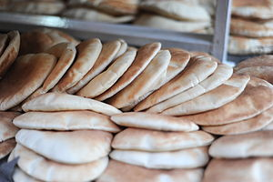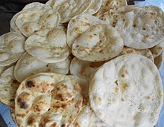
Pita - Middle East, Mediterranean, Greek, Iranian Roti - India, Pakistan, South Asia

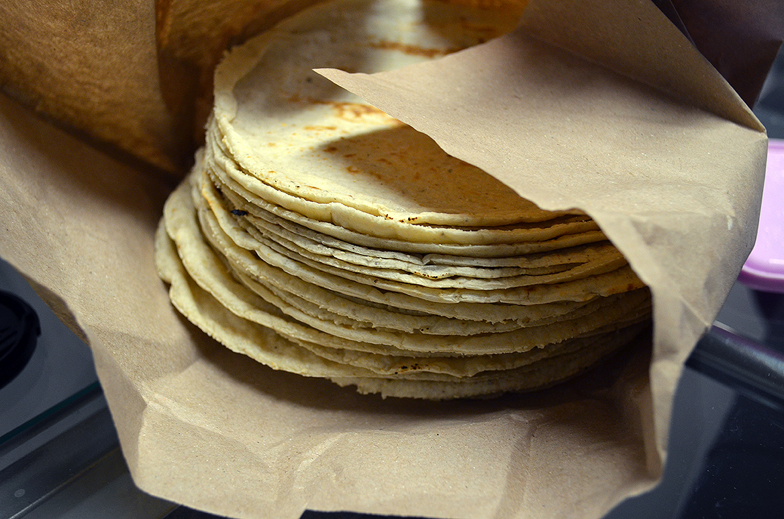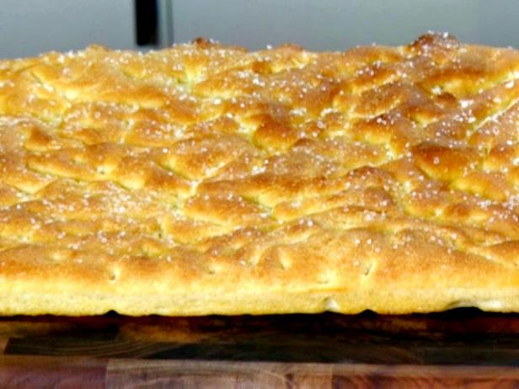
Corn Tortilla - Mexico, Central America Focaccia - Italy

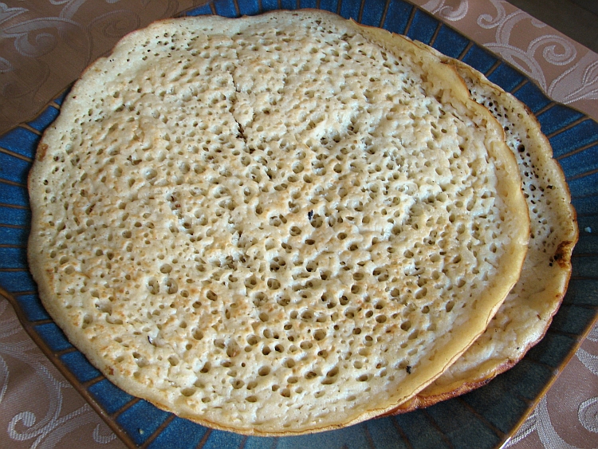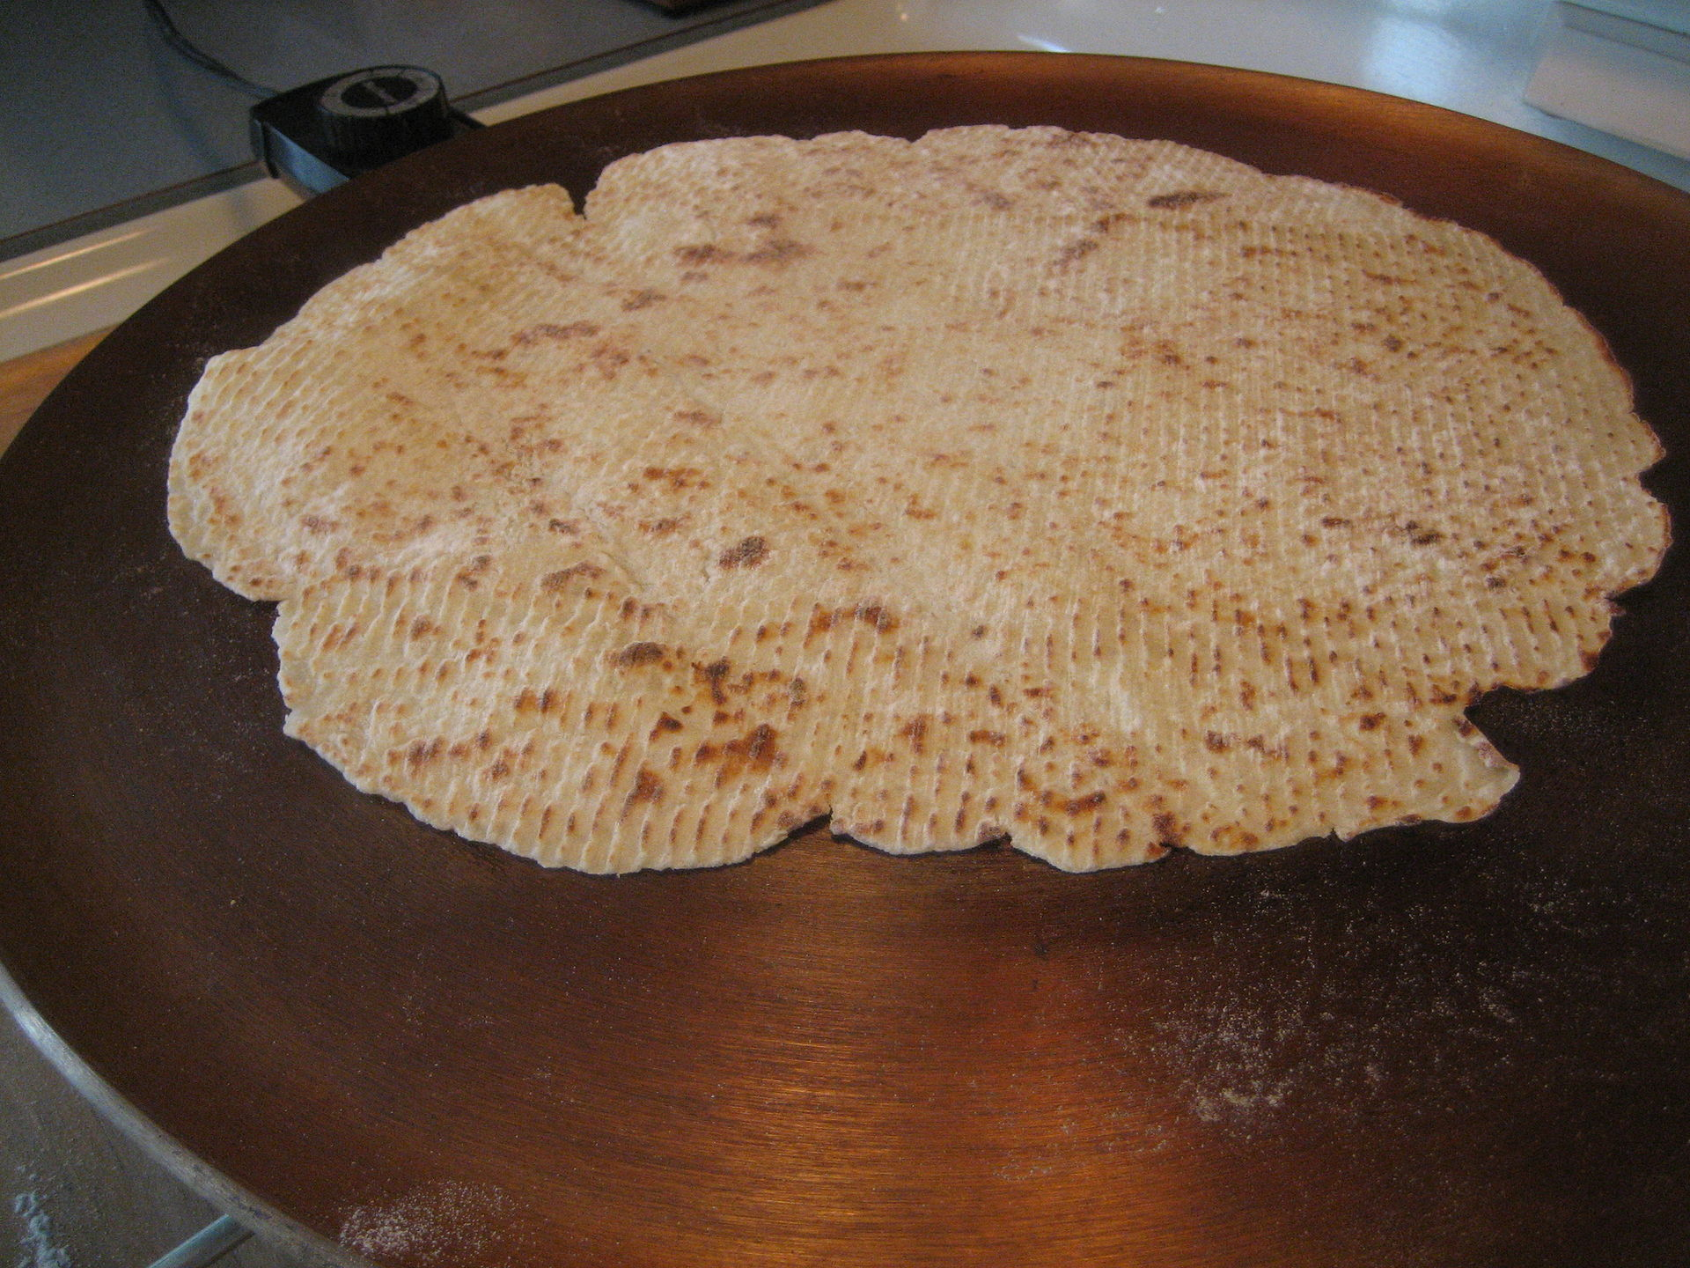
Lahoh - Somali, Yemen, Horn of Africa Lefse - Norway, Scandinavia

Food Story Brainstorming

Your Food
Where are you in your story?
Who is with you?
What are you doing?
How does the food taste? Smell? Sound? Look?
How do you feel making or eating the food?

Food Story Template

Illustration of your food

_____________________________________________________________________

_____________________________________________________________________

_____________________________________________________________________

_____________________________________________________________________

_____________________________________________________________________

_____________________________________________________________________

_____________________________________________________________________

_____________________________________________________________________

_____________________________________________________________________

_____________________________________________________________________

_____________________________________________________________________

_____________________________________________________________________

_____________________________________________________________________

_____________________________________________________________________

_____________________________________________________________________

_____________________________________________________________________

_____________________________________________________________________

_____________________________________________________________________

_____________________________________________________________________

_____________________________________________________________________

_____________________________________________________________________

_____________________________________________________________________

_____________________________________________________________________

_____________________________________________________________________

_____________________________________________________________________

_____________________________________________________________________

_____________________________________________________________________

_____________________________________________________________________

_____________________________________________________________________

