|  |  |  |  |
| --- | --- | --- | --- |
| **Suggested Grade:**  2nd-3rd | **Facilitator:** | **Grade:** | **Lesson Date(s):** |
| **Book Title and Author(s)/Illustrator(s):** Mateo Finds His Wow: A Story of Wonder and Gratitute  **Author:** Gaby Garcia **Illustrator:** Charity Russell | | | |
| **Theme(s)/Big Idea(s):** We can also find something to be grateful for; There is wonder all around us; Gratitude; Creativity | | | |

|  |  |
| --- | --- |
| **VOCABULARY PLAN** | |
| **Focus word & kid-friendly definition: Grateful-** being thankful or having appreciation from what we have or what is around us. | |
| **Image/symbol:** Refer to images at the end of the lesson. Ask children what they see. Explain that these are all examples of things we might be grateful for. | **Gesture:** N/A |
| **Use in context:** I am grateful for many things. I have a big family, nice friends, a comfy bed to sleep in and lots of books in my library at home. I | |
| **Prompt kids to use in context:** Think about a time that you were grateful for something. Stop and Jot 2 things that you have or that is around you that you are grateful for. | |
| **Bridge to book:** Explain that in our story, Mateo is having a rough day. He is having a hard time feeling grateful. | |

|  |  |  |
| --- | --- | --- |
| **BEFORE READING**  *write questions and student interaction (T/T, S/J, Act-it-out)* | | |
| * Review RR expectations * Introduce Book/Author/Illustrator * Teach focus vocab word (See plan above) * Ask 1-2 questions to activate prior knowledge/ solicit predictions | | Explain that today we are reading a book called **Mateo Finds His Wow: A Story of Wonder and Gratitude.** The story is written by Gaby Garcia and illustrated by Charity Russell. Before we read, let’s learn our word of the day. Teach focus word using **vocab plan.** Then, continue below.  **Q1. Have you ever felt like Mateo? Have you had a day where everything seemed to go wrong? What happened? - Turn and Talk**  *Prompt children to Turn and Talk. After 1-2 minutes, bring them back and take a few shares. Explain that now we are going to hear about Mateo and why he is having such a rough time.* |
| **DURING READING**  *write questions and vocab with page numbers and student interaction (T/T, S/J, Act-it-out)* | | |
| * Ask 3-4 questions that target different comprehension strategies (predict, infer, connect, synthesize) * Note opportunities to reinforce focus word. * Identify other potential new vocab to define while reading | **Q1. What problem is Mateo having in the story? -pg.4 (Popcorn)**  *Call on a few volunteers and prompt children to add on, as appropriate. Ideas to look for: He is bored; it’s raining, and he can’t go outside; He ran out of screen time and can’t watch TV or play video games.*  **Q2. Mateo is very focused on what he can’t do. Let’s help him think of some things that he could on a rainy day inside his house. -pg. 10 (Stop and Jot)**  *Prompt children to stop and jot some things that Mateo could do using pictures and words. After 1- 2 minutes, prompt children to hold up boards and call out some of what you see or call on a few students to share what they drew/wrote.*  **Q3. Wow! Something has really changed about Mateo. How is Mateo different now then in the beginning of the story? -pg. 22 (Turn and Talk) Follow-up: Why do you think Mateo is different now? (Popcorn**  *Prompt children to Turn and Talk for 2 minutes. Ask a few students to share their responses and support with details. Share follow-up and call on volunteers to answer.*  **What additional words might you address while reading?**   * Wonder * Curious * Experimented * Acrobat * Delight * Chilaquiles | |
| **AFTER READING**  *write questions and student interaction (T/T, S/J, Act-it-out)* | | |
| * Ask 1 question reflecting on book theme * Make connection to extension activity | | **Q1. Mateo realizes that he can go looking for the wows on purpose. What do you think he means by that? How could we look for wows? -Turn and Talk**  *Prompt children to Turn and Talk. Bring back and take a few shares. Prompts if children are stuck: Remember that Mateo was only looking for things he couldn’t do and focusing on the negative. How did that change? What did he start to notice? How could we look for things to be grateful for or “wowed” by?*  **What will you say to connect theme or big idea to extension activity:** Just like Mateo, we all get frustrated or feel disappointed. Frustration and disappointment are normal, but you can get stuck feeling this way when you focus on what you can’t have or do. Taking the time to appreciate and give thanks for the good that’s around can help turn the page on a grumpy day. Mateo turned his day around when he realized that he had things around him to be grateful for. He was able to experience so many “wows” when he started focusing on what was good instead of bad. |

|  |  |
| --- | --- |
| **EXTENSION ACTIVITY** | |
| **Activity Description**  Book of Wow and Thanks-Students will create a book of things that they are grateful for and that bring them wonder. | **Materials**   * Thanks and Wows Group Brainstorm T-Chart * Hole-punched White Cardstock (4-5 per child) * Art supplies (markers, colored pencils) * String or yarn (1 piece/child) * Optional:   + Scissors   + Glue   + Magazines   + Scissors   + Construction Paper |
| **Introduction**  Use the transition to extension activity above. Then, explain that today for our special activity, they are going to make their own books of wow and thanks. These books will show all the things that we are grateful for or that make us excited. | |
| **Brainstorm (Whole group and/or Individual)**  Display a T-Chart with one column entitled “Thanks” and another column entitled “Wows”. Ask children to recall some of the things that Mateo was grateful for and record. Ask children to recall things that brought him wonder (wows) and record. Work together to brainstorm other things that we have or that are around us that we might be grateful for or that bring us wonder (make us excited or curious). Chart responses. | |
| **Model**  Show children your model “Book of Wow and Thanks”. Each page should be decorated with things that you are grateful for or that bring you wonder. Explain what you chose to put in your book and why.  Image result for grateful for food | |
| **Instructions for Independent Work**  Hand each child cardstock and coloring tools (include additional tools such as magazines, colored paper, scissors and glue, if you choose). Instruct students to write (NAME)’s Book of Wow and Thanks on the cover page and decorate with things that make them excited or grateful. Instruct students to decorate 2 additional pages with more things that make them excited or grateful. If they finish early, they can add additional pages. | |
| **Share Back and Reflection**  Pair students up or break into small groups and prompt to take turns sharing Book of Wows and Thanks. Ask 1-2 students to share something they had in common or that they like about their partners book.  **Optional Reflection Question**: How can we show that we are grateful this week? | |

|  |
| --- |
| **Additional Ideas for Extension Activities**   * Students can create thank you cards for friends, family members or someone in their school * Take children on a “wow walk” outside. Have them notice and draw things in nature or in the neighborhood that bring them wonder |

**FOCUS WORD IMAGE – GRATEFUL**

FOOD

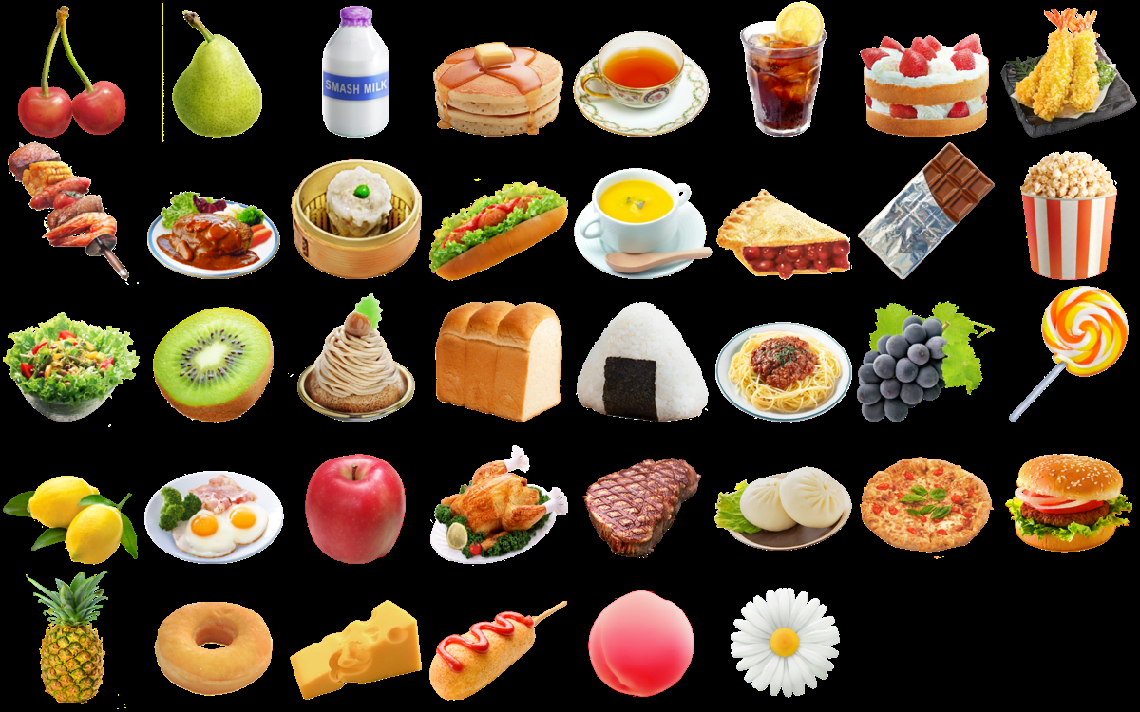

**CLOTHES**

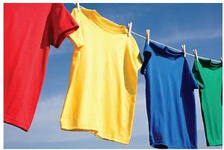

**FRIENDS**

