|  |  |  |  |
| --- | --- | --- | --- |
| **Suggested Grade:** 1st-2nd | **Facilitator:** | **Grade:** | **Lesson Date(s):** |
| **Book Title and Author(s)/Illustrator(s):** The Gruffalo - Author: Julia Donaldson; illustrator: Axel Scheffler | | | |
| **Theme(s)/Big Idea(s):** Being smart is more important than being big or scary; Your size doesn’t matter; You can use your mind/brain to solve big problems; Trickery; Problem-solving | | | |

|  |  |
| --- | --- |
| **VOCABULARY PLAN** | |
| **Focus word & kid-friendly definition:** clever - able to learn things quickly; able to figure tricky things out | |
| **Image/symbol:** see attached images and description | **Gesture:** n/a |
| **Use in context:** see attached images and description - This dog is very clever. It only took him two tries to learn how to jump through the hoop. | |
| **Prompt kids to use in context:** Ask children if theycan think of a character from a book or a movie that they would describe as clever? For example, Hermione from Harry Potter is clever because she uses her mind and reads lots of books to solve big problems. Prompt children to ***Turn and Talk*** about any characters they can think of. Take a few shares with the whole group. | |
| **Bridge to book:** In The Gruffalo, we will meet a few different animals and one that is very clever! Let’s find out who it is and what they do that is so clever! | |

|  |  |  |
| --- | --- | --- |
| **BEFORE READING**  *write questions and student interaction (T/T, S/J, Act-it-out)* | | |
| * Review RR expectations * Introduce Book/Author/Illustrator * Teach focus vocab word ( See plan above) * Ask 1-2 questions to activate prior knowledge/ solicit predictions | | Explain that today we are reading as story called The Gruffalo by Julia Donaldson and illustrated by Axel Scheffler. Before we read, let’s learn our special word of the day. Use the vocabulary plan to teach the word “clever”. Then, continue with Question 1.  **Q1. Take a look at the cover. What do you see? What do you think is going to happen in our story?**  *Prompt children to* ***Turn and Talk*** *about their predictions. Give 1-2 minutes to talk and then ask for a few pairs to share. Answers will vary, but children should be asked to explain their predictions.*  **Q2: Who do you think will be more clever: The Gruffalo or The Mouse? Why do you think so?**  *Prompt children to vote for the Gruffalo or the Mouse. Ask a few children to explain their choices.*  *Begin Read Aloud* |
| **DURING READING**  *write questions and vocab with page numbers and student interaction (T/T, S/J, Act-it-out)* | | |
| * Ask 3-4 questions that target different comprehension strategies (predict, infer, connect, synthesize) * Note opportunities to reinforce focus word. * Identify other potential new vocab to define while reading | **Q1.** **Why do you think Mouse told Fox that roasted fox was the Gruffalo’s favorite food?-pg.3**  *Prompt children to* ***Turn and Talk****. Give 1-2 minutes to talk and then take a few responses as a whole group. Ideas might include: he is tricking the Fox; he wants to scare the fox away. If children get stuck, you might ask why the Fox invites the mouse to lunch and why the mouse might want to scare Fox away.*  **Q2.** **Why do you think Mouse told Fox that roasted fox was the Gruffalo’s favorite food?-pg.3**  *Prompt children to* ***Turn and Talk****. Give 1-2 minutes to talk and then take a few responses as a whole group. Ideas might include: he is trying to scare them away so that they don’t eat him; he wants to trick them; he is playing a joke on them*  **Q3. Uh-oh! Looks like the Gruffalo is real after all. How do you think mouse feels when he see a real Gruffalo? -pg. 14**  *Prompt children to* ***Act it Out*** *with their faces and bodies. Call out some of the emotions you see children acting out.*  **Q4. Do you think the Gruffalo believes that Mouse is the scariest creature in the woods? What makes you think so?**  *Prompt children to vote yes or no. Then, ask a few children to explain their answers. Ideas to reinforce: the Gruffalo laughs at the mouse; the Gruffalo follows the mouse into the woods; the Gruffalo wouldn’t do these things if he was scared of the mouse.*  **Where and how will you reinforce focus word? What additional words might you address while reading?**   * The focus word is reinforced through the before, during and after reading questions.   **Additional Words**   * Stroll-a walk * Creature-an animal * Astounding- surprising * Fled-ran away | |
| **AFTER READING**  *write questions and student interaction (T/T, S/J, Act-it-out)* | | |
| * Ask 1 question reflecting on book theme * Make connection to extension activity | | **Q1. How did the mouse prove that he was clever in the story?**  *Prompt children to* ***Turn and Talk.*** *Give 1-2 minutes to talk and then take a few responses as a whole group. Ideas might include: mouse made all of the other animals believe that the Gruffalo was real; mouse tricked the Gruffalo into thinking he was the scariest animal in the woods; he uses the Gruffalo to scare the other animals away.*  **Q2.** **What would you do if you ever came across a Gruffalo?**  *Prompt children to* ***Act Out*** *with their faces and bodies what they would do. Call out some of the emotions and actions you see.*  **What will you say to connect theme or big idea to extension activity:** We got a chance to meet a clever little mouse that showed that it doesn’t matter how big our small you. Mouse could outsmart animals that were bigger and scarier, by using his brain and being clever. For our activity today, we are going to get a chance to act out the different animals in our story, but you get to use your smart brains and add your own personalities! |

|  |  |
| --- | --- |
| **EXTENSION ACTIVITY** | |
| **Activity Description**  Children will use finger puppets to act out scenes from The Gruffalo. | **Materials**   * Gruffalo Finger Puppet Template (1 set/child) * Scissors * Tape or Glue |
| **Introduction**  Explain that you are going to give them a sheet with characters from The Gruffalo. We are going to make them into finger puppets and then use them to act out scenes from our story. | |
| **Brainstorm** (Whole group and/or Individual)  N/A | |
| **Model**  Model how to put together one of the puppets, explaining each step. Then, show children a complete set and display. It might be useful to put one completed puppet on each table. | |
| **Instructions for Independent Work**  Puppets:  Hand out sheets, scissors and tape/glue. Give children 10 minutes to cut out and put together their set of puppets. Support any children who are having difficulty.  Acting Out:   * Split the children into groups of 6. (Narrator, Gruffalo, Mouse, Fox, Snake, Owl) If you do not have enough students for even groups of 6, remove characters from the groups as needed. Be sure to at least have a group of 4 (Narrator, Gruffalo, Mouse and one of the other three animals) * Tell children that they should each choose a character to act out. (If you are worried that children will argue, feel free to pre-assign characters in each group) * Explain that they will have 10 minutes to talk about how they want to act out The Gruffalo and to practice. They can put the story in their own words and personalities, but they should still retell the main events story. (Review and write on a large chart, if needed) * Send groups to a part of the room for practice and float to support and redirect, as needed. * Once prep time is up, allow each group to act out their version of The Gruffalo. | |
| **Share Back and Reflection**  Ask children to reflect on their favorite part of The Gruffalo. Prompt them to **Turn and Talk** with a neighbor. Give 1-2 minutes to talk and then take a few shares as a whole group. | |

**FOCUS WORD IMAGE - CLEVER**

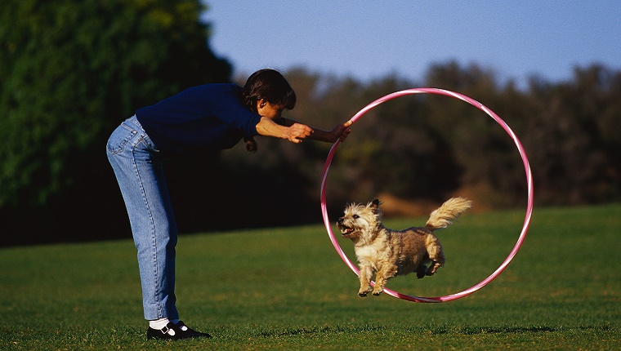

This dog is very clever. It only took him two tries to learn how to jump through the hoop.