Suggested Grade:  K-3rd | Facilitator: | Grade: | Lesson Date(s):
Book Title and Author(s)/Illustrator(s): Hey, Wall: A Story of Art and Community Written by Susan Verde and Illustrated by John Parra
Theme(s)/Big Idea(s): community; community transformation; working together; we can transform our communities through art

VOCABULARY PLAN
Focus word & kid-friendly definition: Transform- to make a big change

Note: If the facilitator wants to expand the definition, they can share that sometimes this change is in how something or someone looks. Sometimes it can be how something or someone thinks, speaks or acts.
Image/symbol: Show children before and after images at the end of the lesson. Ask them how each one has transformed. | Gesture: N/A
Use in context: See Image/Symbol section
Prompt kids to use in context: Think about a time that you’ve seen something change or transform. Prompts kids to Turn and Talk to share with a neighbor. Take a few responses aloud.
Bridge to book: In today’s story, a community transforms a part of their neighborhood. Let’s read and see what they do.

BEFORE READING
write questions and student interaction (T/T, S/J, Act-it-out)
- Review RR expectations  - Introduce Book/Author/Illustrator  - Teach focus vocab word ( See plan above)  - Ask 1-2 questions to activate prior knowledge/ solicit predictions |  | Explain that today we are reading a story called Hey, Wall: A Story of Art and Community. It was written by Susan Verde and illustrated by John Parra. Explain that before you begin the story, we are going to learn our special word of the day. Teach the focus word using the plan above and then continue below.  Q1. Prompt children to take a look at the cover and share what they notice. Then, prompt them to make predictions about what will happen in the story. (Hands-up/Volunteer)  Call on volunteers to share predictions. Encourage children to share clues to support predictions.
DURING READING
write questions and vocab with page numbers and student interaction (T/T, S/J, Act-it-out)
- Ask 3-4 questions that target different comprehension strategies (predict, infer, connect, synthesize)  - Note opportunities to reinforce focus word.  - Identify other potential new vocab to define while reading | Q1. How do the narrator and other people in the community feel about the wall? (Act it Out) Follow-up: What did you hear in the story or see in the pictures that makes you think they feel this way? Why might they feel this way? (Hands-up/Volunteer)-pg. 6  Prompt children to Act it Out with their faces and bodies. Call out what you see and then invite a few children to share what emotions they were acting out. Then, ask the follow-up questions and call on volunteers to respond. Refer back to the story as needed to support.  Q2. What do you think the narrator means when they say that the flowers are “reaching for the sunlight”? (Turn and Talk) Follow-up: Why would the children cheer for the flowers? (Hands-up/Volunteer)-pg.10  Prompt children to Turn and Talk. After 1-2 minutes, call on a few pairs to share ideas. Ideas to look for: It means that they are growing; they are growing up towards the sky. Ask the follow-up question and call on volunteers.  Q3. What does the narrator mean when they say that the wall “doesn’t share its stories”? (Turn and Talk) Follow-up: Are there any walls in your neighborhood that tell stories? Where are they? What stories do they tell? (Hands-up/Volunteers)-pg. 14  Prompt children to Turn and Talk. After 1-2 minutes, call on a few pairs to share ideas. Ideas to look for: the wall is blank; it doesn’t have any pictures or images that tell about the community. Ask the follow-up question and call on volunteers.  Q4.What do you think the narrator is going to do? What makes you think so? (Hands-up/Volunteer)-pg. 18  Call on volunteers to share predictions. Invite other children to agree, disagree and add on to each other’s ideas.  What additional words might you address while reading?  - Neighborhood  - Lonely  - Change  - Creator  - Sketches  - Memories  - Imagination  - Canvas  - Creations
AFTER READING
write questions and student interaction (T/T, S/J, Act-it-out)
- Ask 1 question reflecting on book theme  - Make connection to extension activity |  | Q1. Think about the wall in the beginning of the story and at the end of the story. How did the community transform the wall? Follow-up: How do you think they feel about the wall now? How is this different from the beginning of the story? (Hands-up/Volunteer)  Pose the first question and then call on volunteers. Invite other children to add on. Then, ask follow-up questions and call on new volunteers.  Q2. How can we use art to make our schools and neighborhoods better? (Turn and Talk)  Prompt children to Turn and Talk. After 1-2 minutes, take shares from pairs.  What will you say to connect the theme or big idea to extension activity: The community came together and used art to transform a part of their neighborhood into something beautiful that represented them all. For today’s activity, we are going to think about art we would like to see in our own schools and neighborhoods.

EXTENSION ACTIVITY

Activity Description: Community Change Murals  Children will create a group mural that represents images they would like to see in their schools and neighborhoods. Each child will design a square individually that will be taped to other squares on poster or butcher paper to make a large group mural. | Materials  - Chart Paper for Group Brainstorm  - Model Mural Square  - Sketch Paper (1 per child)  - 8” X 8” Cardstock Squares (1 per child)  - Coloring tools (crayons, colored pencils) *You can also have children paint the squares as long as extra prep, clean-up, and drying time is accounted for.  - Tape or glue  - Colored poster board or butcher paper  - Printed pictures of murals from the community (see examples attached)
Introduction

Direct group’s attention to pictures of murals. These can be shown one by one or taped to a chart paper. Ask the group to give you a thumbs up if they have ever seen any paintings or drawings on buildings around their neighborhood like the ones in the pictures. Ask a few children to share what kinds of drawings they have seen. Explain that these paintings are called murals and that they are painted by artists to add beauty to the community and sometimes to share a message using pictures. A mural is a work of art, usually a painting, that is done directly on a wall or ceiling, or
another surface that is hung on a wall. We are going to think about what we would paint if we wanted to transform the walls in our own school and neighborhood.
Brainstorm

Direct group’s attention to large chart paper with the title “Community Mural Brainstorm”. Pose this question to the group: “If you could transform your community with drawings or paintings, what would you draw or paint?” “What kinds of pictures would you like to see around your neighborhood?” Take responses popcorn style and write on chart paper. As an alternative, you can have children brainstorm individually first using a stop and jot. Then, use these responses to compile a group brainstorm chart.

Model

After brainstorming ideas as a group, explain that in a few minutes you are going to give them sketch paper and pencils to practice drawing the picture that they want to add to our community mural. Explain that once they finish practicing, they will each get a special square to put their final drawing on. Explain that after everyone is finished, you are going to tape them all together to create a whole group mural with each of their drawings. Show a pre-drawn sketch (before any color added) and a completed drawing as models and then hang where children can see them. Explain what you drew and why you would want this picture in your community (Emphasize that yours is just an example and that they should draw what they want to see in the community)

Hand out sketch paper and pencils. Give 5-10 minutes for brainstorming with a timer set, depending on group progress.
Instructions for Independent Work

Once brainstorm time is up, give out cardstock squares and coloring tools. Give 15-20 minutes to complete the mural square. If some children finish quickly, they can complete a second square.
Share Back and Reflection (8-10 minutes)

After materials have been cleaned up, explain that they will now have a chance to share what they drew for our community mural. Assign pairs and instruct groups to Turn and Talk about what they drew. Explain that they should share what they draw AND why they would want that picture in the school or neighborhood. Rotate to ensure that everyone is getting a chance to share. Once Turn and Talk is complete, call on a couple of pairs to share what each other drew. Ask group: How might adding these pictures change or transform our community? What are some other ways that you might change or transform your community? Take responses from volunteers. Group Leaders can share ideas as well, if children are stuck. Thank children for a great Ready Readers class and close out session.

*After the lesson, group leaders should put the squares together on a colored poster or butcher paper background to show children at the next lesson. Ideally, they can find some place to hang it in the building.

Additional Ideas for Extension Activities

- Group can color or paint their images on rolled out butcher paper after they brainstorm on sketch paper. Group would need a space where kids could each work on their own piece of the paper at the same time.

- Have children write a poem about an object, pretending to speak to that object. Encourage them to ask the object questions. They can also share thoughts, ideas and opinions with the object.

Focus Word Images

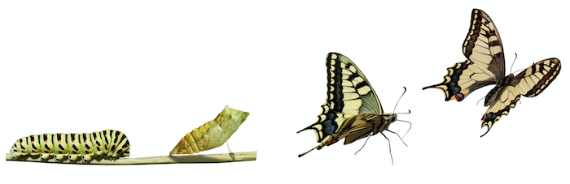

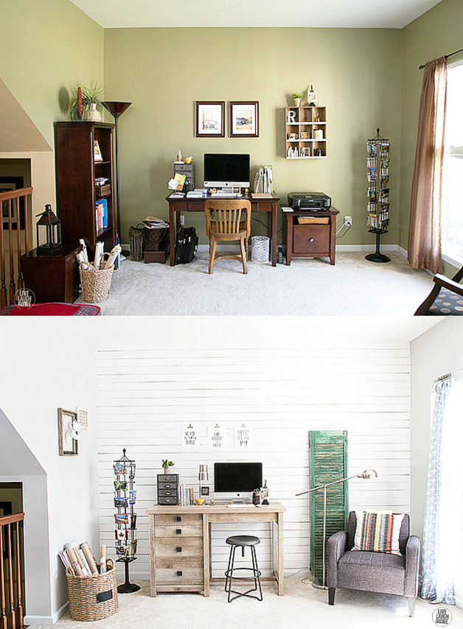

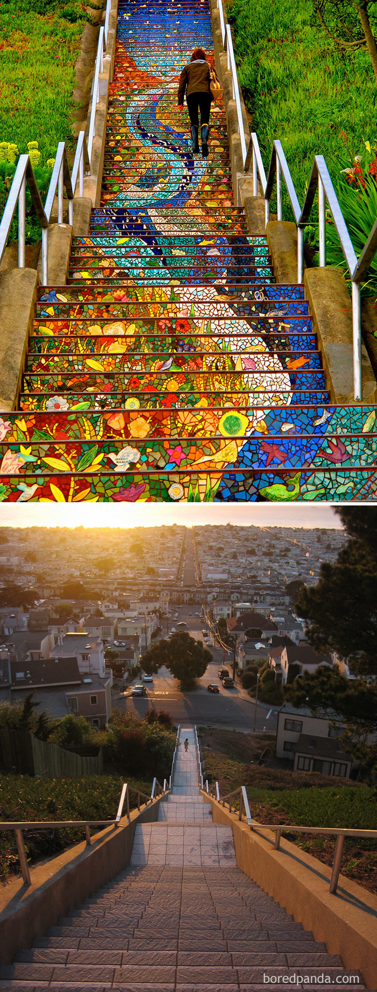

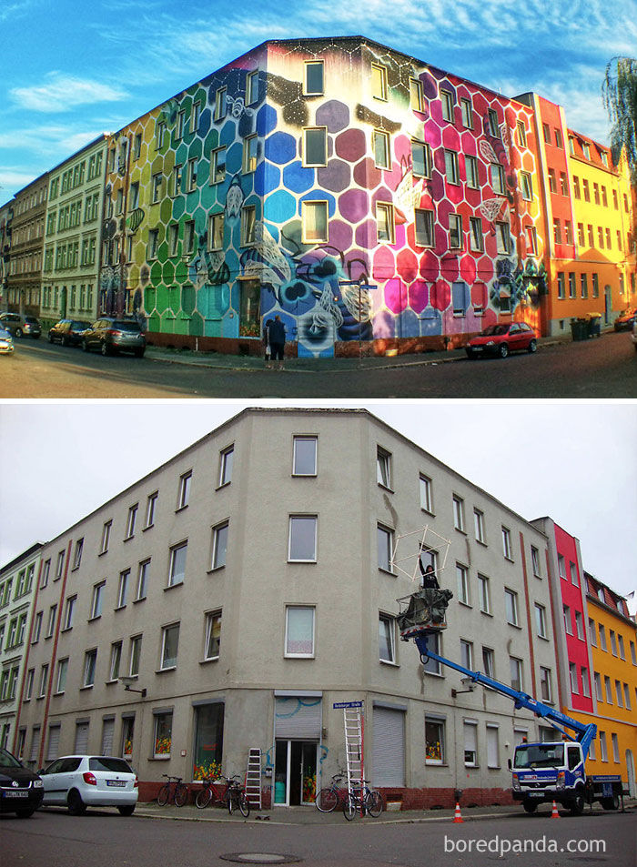



Sample Murals

