Suggested Grade:  K-1st | Facilitator: | Grade: | Lesson Date(s):
Book Title and Author(s)/Illustrator(s): Jabari Tries Written and Illustrated by Gaia Cornwall
Theme(s)/Big Idea(s): Ingenuity; Learning from mistakes; Teamwork; STEM; It’s okay to make mistakes; It’s okay to need and ask for help

VOCABULARY PLAN
Focus word & kid-friendly definition: Invent-create something new that no one else has created before
Image/symbol: Show children pictures at the end of the lesson. Ask children to point out what each person has invented. | Gesture: N/A
Use in context: Facilitators should share an example from their own experience. For example: “When I was young, I worked with my friends to invent or create new dance moves that no one had seen before, just like dancers are doing today.
Prompt kids to use in context: If you could invent something new, what would it be? (Stop and Jot)
Bridge to book: In our story, Jabari is working on a new invention. Let’s read and find out what happens.

BEFORE READING
write questions and student interaction (T/T, S/J, Act-it-out)
- Review RR expectations  - Introduce Book/Author/Illustrator  - Teach focus vocab word ( See plan above)  - Ask 1-2 questions to activate prior knowledge/ solicit predictions |  | Explain that today we are reading a story called Jabari Jumps. It was written and illustrated by Gaia Cornwall. Explain that before you begin the story, we are going to learn our special word of the day. Teach the focus word using the plan above and then continue below.  Q1. The title of our story is Jabari Tries. Take a look at the cover. What do you think Jabari is going to try to do? (Turn and Talk)  Prompt children to Turn and Talk. After 1-2 minutes, take shares from pairs.
DURING READING
write questions and vocab with page numbers and student interaction (T/T, S/J, Act-it-out)
- Ask 3-4 questions that target different comprehension strategies (predict, infer, connect, synthesize)  - Note opportunities to reinforce focus word.  - Identify other potential new vocab to define while reading | Q1. How do you think Jabari feels when his flying machine crashes?-pg.6 (Act it Out) Follow-up: What would you do next if you were Jabari? (Hands-up/Volunteer)  Prompt children to act out with their faces and bodies. Call out what you see and then invite a few children to share. Then, ask the follow-up question.  Q2. Do you think Jabari’s new ramp is going to help his flying machine stay in the air?-pg. 11 (Thumbs-up/Thumbs-down) Follow-up: Why do you think so? (Turn and Talk)  Note: Be sure to stop on page 11 right after “Jabari was ready”. If you read past this point, the question will get answered. You should also close the book, so that the picture is hidden. Invite children to vote using thumbs up or thumbs down. Then, ask the follow-up question and prompt children to Turn and Talk. After 1-2 minutes, take shares from pairs.  Q3. How is Jabari feeling now? What did we hear in the story or see in the pictures that gives us clues about how he is feeling?-pg 16 (Turn and Talk) Follow-up: Why is he feeling this way? (Hands-up/Volunteer)  Prompt children to Turn and Talk. After 1-2 minutes, take shares from pairs. Then, ask the follow-up question. Call on volunteers to share.  Q4. Jabari’s dad gave him something to try when he was feeling frustrated to help calm his body down. Let’s try it together.-pg 20 (Act it Out) Follow-up: What are some other things we can do if we are feeling mad, upset or frustrated?  Invite children to take a deep breath in and then blow it all out. Repeat a few times and ask them to notice how their bodies feel. Then, ask the follow-up question.  What additional words might you address while reading?  - Concentrating  - Inventors  - Creativity  - Engineers  - Sketched  - Partner  - Patience  - Tinker
AFTER READING
write questions and student interaction (T/T, S/J, Act-it-out)
- Ask 1 question reflecting on book theme  - Make connection to extension activity |  | Q1. Why did Nika keep saying “me” over and over in the story? (Turn and Talk)  Prompt children to Turn and Talk. After 1-2 minutes, take shares from pairs.  Q2.How did Jabari feel about Nika helping him in the beginning of the story? How did this change? Follow-up: Why did Jabari change his mind? (Hands-up/Volunteers)  Call on volunteers and then invite other children to add on. Then, ask the follow-up questions and call on new volunteers.  Q3. Why was Jabari able to make his machine fly in the end? Follow-up: What do you think Jabari learned in the story? (Turn and Talk)  Prompt children to Turn and Talk. After 1-2 minutes, take shares from pairs. Then, ask the follow-up question. Call on volunteers to share.  What will you say to connect the theme or big idea to extension activity: Jabari and Nika worked together to build a flying machine that really worked! For today’s special activity, you are going to have the chance to create a special flying machine.

EXTENSION ACTIVITY

Activity Description  Straw Rockets  Children will decorate and build a straw rocket. | Materials  - Straws  - Tape or glue dots  - Plastic pipettes (or straws with a larger diameter than the other set of straws)  - Markers, crayons, or colored pencils  - Scissors  - Rocket Template (Half sheet per child with 2 rockets)  Prep required:  - Cut the bottoms off of the pipettes until they are the same length as the paper rockets. If you don’t have any plastic pipettes, you can use a straw instead. Just make sure this straw is wider than the other straw you’ll be using for launching. Cut the straw to fit the length of the rocket. See examples below. You can also have children cut these during the lesson.  Option 1 w/ pipettes  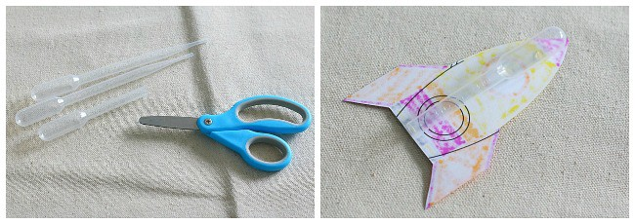  Option 2 w/ larger straw  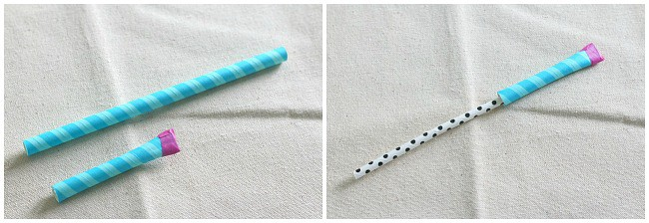
Introduction

Explain that we are going to be creating our own straw rockets and practicing different ways to launch them!

Model

Show children an example of a complete straw rocket. (This should be compiled ahead of time and tested)

Instructions for Independent Work

- Hand out rocket templates and coloring tools Give children time to decorate 2 rockets
- Hand out scissors and give children time to cut out their rockets. Assist, as needed
- Hand out pipettes or larger cut straw, glue dots or strips of tape. Show children how to tape to the back of their rockets.
- Instruct child to slip straw into the pipette or larger straw that they tape to the back of the rocket

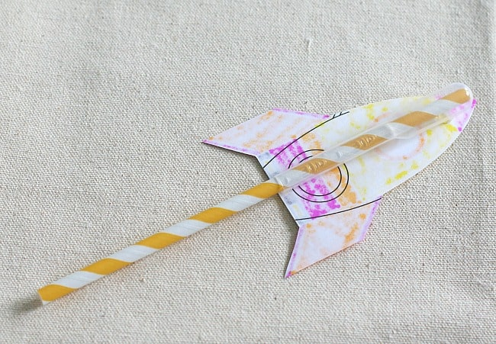

- Have children practice launching their rocket by blowing into the straw. Encourage them to try blowing at different angles and maybe even bendng the straw in different ways.
- Optional: After a few launches, have children tape a third fin to the rocket to see if a makes a difference in how it flies

Alternative: For a more creative version, give children a variety of materials (paper, cardstock, decorations, scissors, tape, glue) and have them create their own rockets instead of using a template. Show a few pictures to give ideas of different kinds of rockets to support. Then, continue with the instructions using the pipettes and straws for launching.

Share Back and Reflection

Have children reflect using the questions below:
- How did blowing at different angles change how your rocket launched or flew?
- Did adding another fin change how your rocket launched or flew? How did it change?
- What else might you add to your rocket?

Additional Ideas for Extension Activities

- Calm down cards (See Horrible Bear Lesson Plan)

- Affirmation airplanes (See After the Fall Lesson Plan)

- Clothespin airplanes (See Hanks Big Day Lesson Plan)

- Maker Challenge (See Boxitects Lesson Plan)

